Capabilities of Polyamide + glass fiber reinforced injection molding

# Introduction

Polyamide (PA) and glass fiber (GF) are two materials that have revolutionized injection molding industries with their remarkable properties. Polyamide is a class of thermoplastics with high mechanical strength, chemical resistance, wear resistance, and high melting point. This is why polyamides are an ideal choice for applications demanding toughness and temperature resistance. They are also commonly known as nylon. Glass fibers are the most common of all reinforcing fibers for polymer matrix composites. It is used in composites and plastics to enhance their mechanical attributes due to its high strength-to-weight ratio and stiffness. These two materials are combined into a single blend known as PA+GF to create products with a unique set of properties. All these properties make this material suitable for use in parts that are under high static loads over long periods in high-temperature conditions. This comprehensive article excavates deep into the capabilities of PA+GF plastic injection molding, its composition, advantages, injection molding process, real-world applications, challenges, and its emerging future.

# The composition of PA+GF

PA+GF, often referred to as Glass-filled nylon or glass-filled polyamide, is a composite material derived from nylon (a synthetic polyamide thermoplastic). Within this composite, short glass fibers are intimately dispersed within a nylon matrix. This blending of nylon with glass fibers creates a distinctive material composition with remarkable properties. There are various grades available today and most of them are either based on Polyamide 6 or 66.

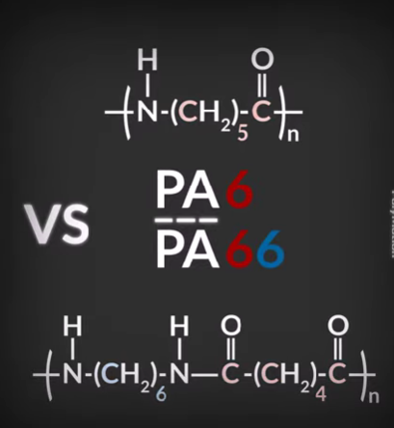

Figure 1Molecular structure of Polyamide 6 and Polyamide 66 (source: https://www.youtube.com/shorts/mqOkPumHDVg)

Some of the popular blends based on the Polyamide 6 or 66 and glass fiber with different compositions are listed below:

1. **PA66 GF30**: PA66 GF30 is a special material made by mixing polyamide 66 with 30% glass fiber. This combination results in a material that's incredibly strong and holds its shape well. Also, it can resist bending over time. It can also handle high temperatures because the glass fibers help the nylon stay stable even when it's hot.

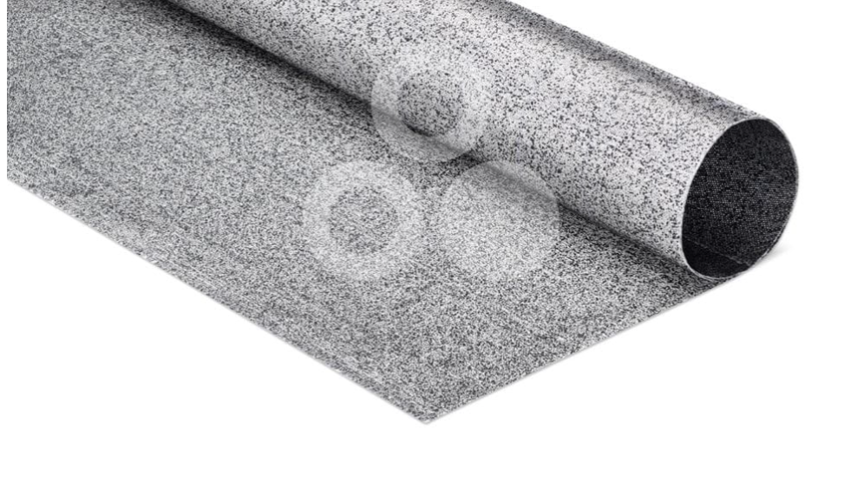

Figure 2 TECATEC PA66 GF43 T280 black (source: https://www.ensingerplastics.com/en/composites/tecatec-pa66-gf43-t280-black)

1. **PA66 GF50**: PA66 GF50 is like PA66 GF30, but it's even stronger because it's made with 50% glass fiber. It can withstand very high temperatures, up to around 130°C or 266°F. It's tough, doesn't warp easily, resists chemicals, and keeps its shape.

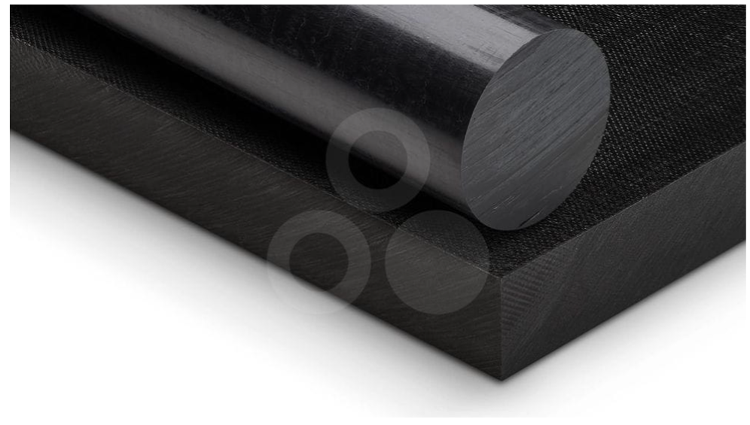

Figure 3TECAMID 66/X GF50 black( source:https://www.ensingerplastics.com/en/shapes/pa66-tecamid-66-gf50-black)

1. **PA 6 GF25**: PA 6 GF25 is a bit different. It's polyamide mixed with 25% glass fiber. This one has less glass fiber, so it's good for making things with larger shapes. It's also very stiff, strong, and rigid, which makes it great for various applications.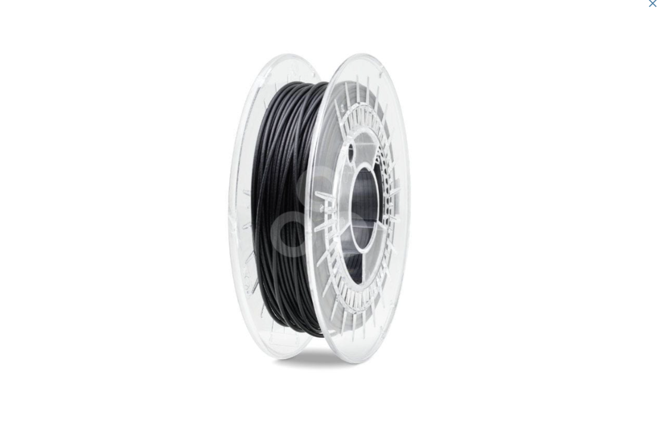

Figure 4PA6 GF30 FILAMENT (source :https://www.ensingerplastics.com/en/filaments/tecafil-pa6-gf30-black-1-75mm)

## PA+GF (Glass-filled polyamide) properties

Significant changes in mechanical and thermal properties are observed when polyamides are reinforced with glass fibers. The table below shows the value of different properties for the different compositions of polyamide to glass fibers.

Table 1Glass filled Polyamide properties (source: https://www.vem-tooling.com/glass-filled-nylon/)

|  |  |  |  |
| --- | --- | --- | --- |
| Glass Filled Polyamide Properties | | | |
| **Properties** | **PA66 GF30** | **PA66 GF50** | **PA6 GF25** |
| **Tensile Strength** | 91 Mpa | 115 Mpa | 96 Mpa |
| **Density** | 1.34 g/cm3 | 1.61 | 1.33 |
| **Melting Temperature** | 254 0C | 256 | 217 |
| **Moisture absorption Rate** | 0.2 | 0.2 | 0.2 |
| **Creep Resistance** |  |  |  |
| **Weathering Resistance** |  |  |  |

Glass-filled Nylon is undoubtedly superior to standard Nylon. With its significantly higher tensile strength, greater rigidity, and better toughness, there is no question that Glass-filled Nylon is the clear winner. If you want the best performance for your applications, choose Glass-filled Nylon without hesitation. It also exhibits excellent thermal stability, chemical resistance, and dimensional stability under long-term stresses.

Table 2 Polyamide vs. glass-fiber Polyamide (source:https://www.vem-tooling.com/glass-filled-nylon/)

|  |  |  |
| --- | --- | --- |
| Polyamide VS Glass Fiber + Polyamide | | |
| **Properties** | **Polyamide** | **Glass-filled polyamide** |
| **Tensile strength** | Standard | Increased |
| **Stiffness** | Standard | 80% More than Standard Polyamide |
| **Rigidity** | Standard | Increased |
| **Hardness** | Standard | Increased |
| **Creep Strength** | Standard | Increased |
| **Dimensional Stability** | Standard | Increased |
| **UV-light resistance** | × |  |
| **Abrasiveness** | × |  |
| **Weight** | Lightweight | 15% heavier than standard polyamide |

# Advantages of Using PA+GF in Injection Molding

The advantages of molding with glass fiber reinforced nylon material, as opposed to general-purpose nylon, include:

* **Improved Mechanical Strength**: Glass-filled nylon significantly increases strength which makes it capable of withstanding greater external forces. The experimental results below clearly show that elastic modulus, yield strength, tensile strength, and fracture strength significantly increase with the increment of glass fiber percentage.

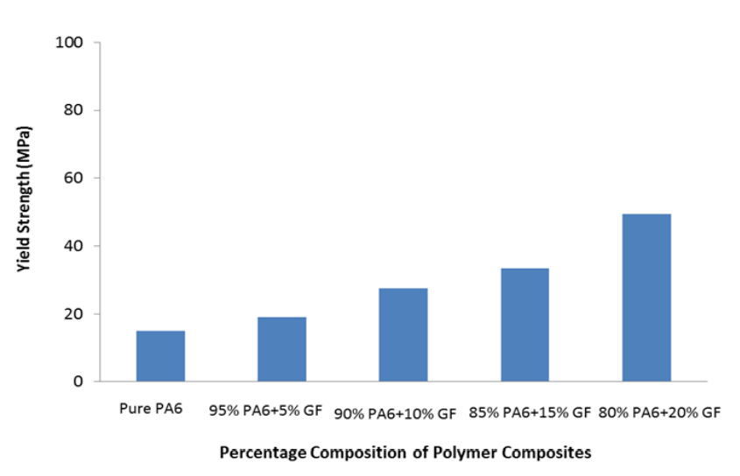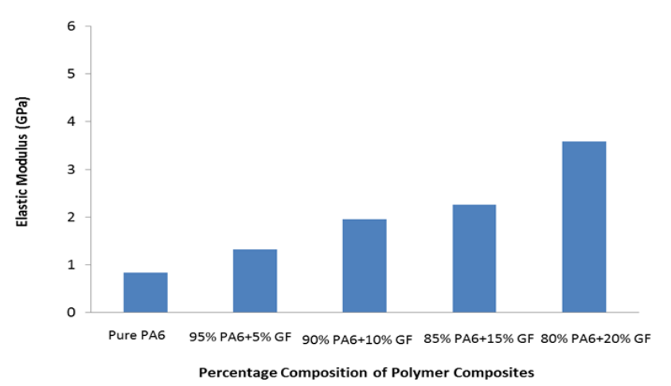

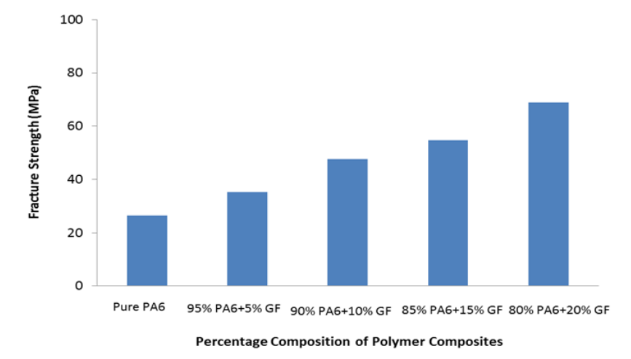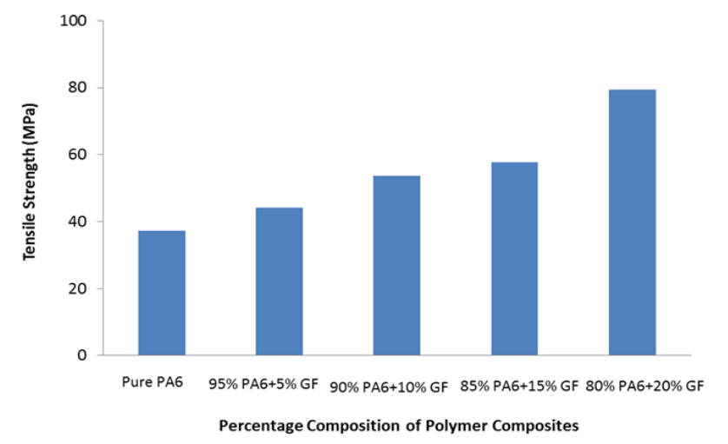

Figure 5 comparison of mechanical properties of glass-filled polyamides with various glass fiber compositions (source :https://iopscience.iop.org/article/10.1088/1757-899X/114/1/012118)

* **Improved Hardness**: The material exhibits improved hardness that contributes to its overall durability and resistance to wear.
* **Greater Stiffness**: Glass fiber-reinforced nylon offers increased stiffness enhancing its ability to maintain its shape and integrity. Glass-filled nylon offers up to 80% more stiffness than regular nylon.
* **Enhanced Thermal Resistance**: Glass-filled nylon has a lower thermal expansion rate such that it ensures stability and minimal deformation even when it is exposed to high temperatures. The thermal expansion rate of glass-filled nylon is only about half that of standard nylon, so it is less likely to deform due to temperature changes.
* **Creep and Wear Resistance**: It excels in resisting both creep (gradual deformation under load) and wear, ensuring long-term performance and reliability.
* **Dimensional Stability**: Glass-filled nylon maintains its intended size and shape under varying conditions, making it suitable for applications demanding precision.
* **Mechanical Damping Properties**: The material effectively absorbs vibrations and shocks, improving the overall performance of molded parts.
* **Chemical Resistance**: Glass-filled nylon is more resistant to chemical exposure making it suitable for environments where contact with corrosive substances is a concern.
* **Cost-effectiveness**: One advantage of using glass fiber-reinforced polyamide compared to pure polyamide is its cost-effectiveness. PA+GF blends often provide improved mechanical and thermal properties at a relatively lower cost compared to alternative materials with similar performance characteristics. Glass-filled polyamide injection molding is cost-effective due to high productivity, complex parts, and reduced assembly costs.

# The Injection Molding Process for PA+GF

## Material Preparation and Considerations:

To achieve successful injection molding, it's imperative to prioritize material preparation and selection. Without these critical aspects, the end result may fail to meet your expectations. So, before you start the injection molding process, make sure you understand the importance of proper material preparation and selection.

* **Polyamide Selection**: The choice of polyamide resin is fundamental. Polyamides are known for their balance of properties making them suitable for various applications. PA6 and PA66 are common choices for PA+GF injection molding due to their compatibility with glass fibers.

Table 3 Comparison between polyamide 6 vs Polyamide 66

|  |  |  |
| --- | --- | --- |
| Material | PA 6 | PA 66 |
| Melting point | lower | higher |
| Crystalline | less | more |
| Shrinkage | Lower mold shrinkage | Greater mold shrinkage |
| Heat deflection temperature | lower | higher |
| Water absorption rate | higher | lower |
| Chemical resistance to acids | poor | Good |

* **Glass Fiber Reinforcement**: Glass fibers are typically supplied as short strands or pellets which are added to the polyamide resin. The ratio of glass fibers to polyamide varies based on the desired properties of the final product.
* **Additives**: Depending on the specific requirements, additives like stabilizers and colorants can be introduced to the mix. These stabilizers help prevent the degradation of the polymer during processing, ensuring the material's longevity.

## Step-by-Step Process Guide:

After the material preparation and pre-consideration, the injection molding process for PA+GF is done by following a systematic procedure:

* **Material Preprocessing**: The polyamide resin and glass fibers are precisely blended in predetermined proportions. This mixture is typically in pellet form making it convenient for loading into the injection molding machine's hopper.
* **Injection Molding Machine Setup**: The injection molding machine is configured with the appropriate mold and heating zones. Mold design plays a crucial role in achieving the desired part shape and properties.
* **Injection**: The blended material is introduced into a heated barrel of the machine, where it is melted to form a viscous molten resin. This molten resin is then injected into the mold cavity under high pressure.
* **Cooling and Solidification**: After injection, the molten material rapidly cools and solidifies within the mold. Precise control of the cooling process ensures that the part maintains its intended shape and properties.
* **Ejection**: Once cooled, the mold opens and the finished part is ejected. It is often done with the assistance of ejector pins or mechanisms to prevent damage during removal.

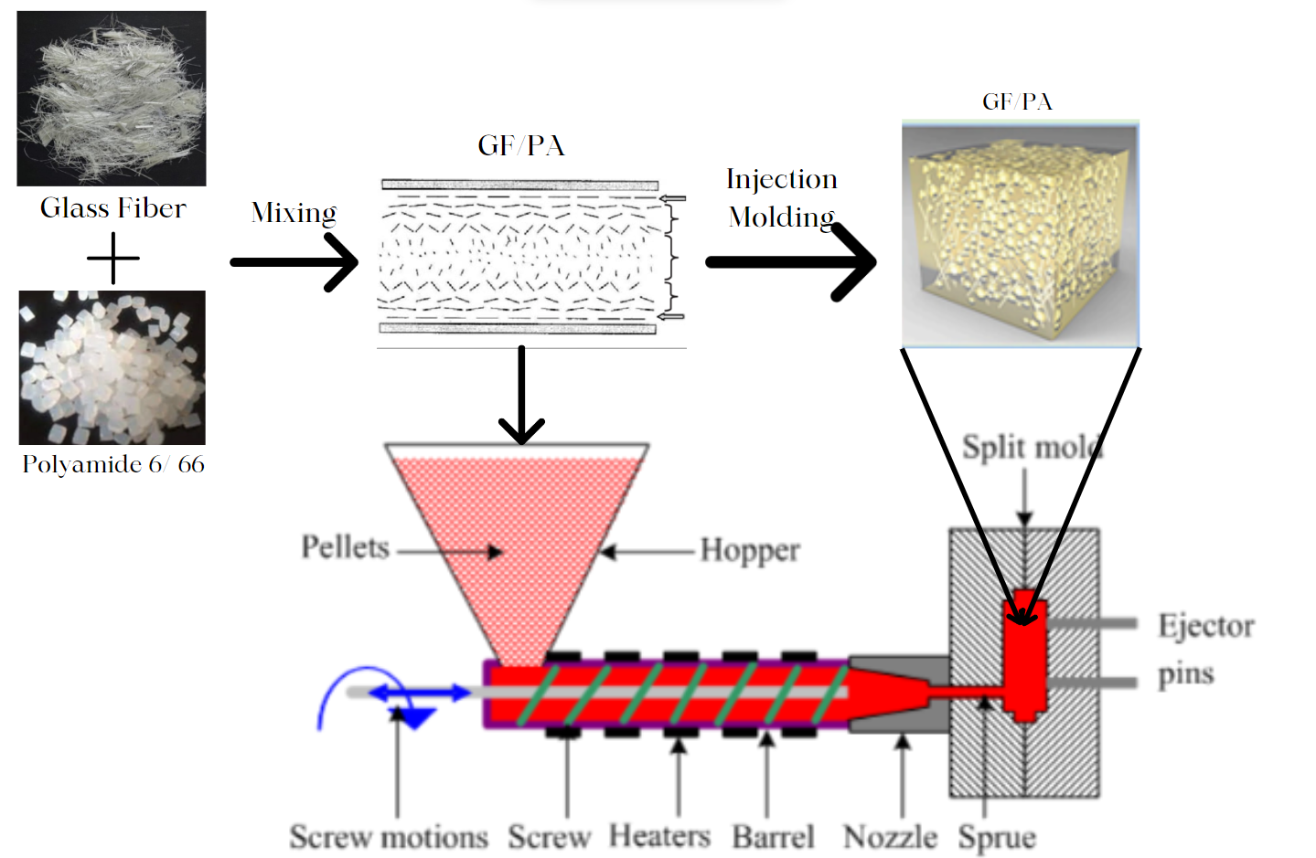

Figure 6 Workflow diagram of PA+GF injection molding

## Special Considerations When Molding PA+GF:

Molding PA+GF presents unique considerations:

* **Fiber Orientation**: Proper mold design and process parameters are crucial to maintain consistent fiber orientation throughout the part. Fiber alignment impacts mechanical properties.
* **Air Venting**: The addition of glass fibers can trap air during injection. To prevent defects like voids, mold design must incorporate air vents to allow trapped air to escape.
* **Material Flow**: Glass fibers can alter material flow characteristics. Mold design should account for these changes to ensure uniform filling of the cavity.
* **Cooling Rate**: Controlling the cooling rate is essential for achieving desired material properties. Rapid cooling can lead to warpage while slow cooling may result in improved part dimensions and reduced residual stresses.
* **Post-Processing**: post-processing steps such as trimming, surface finishing, or assembly may be necessary to meet specific quality and functional requirements.

# Applications and Use-Cases

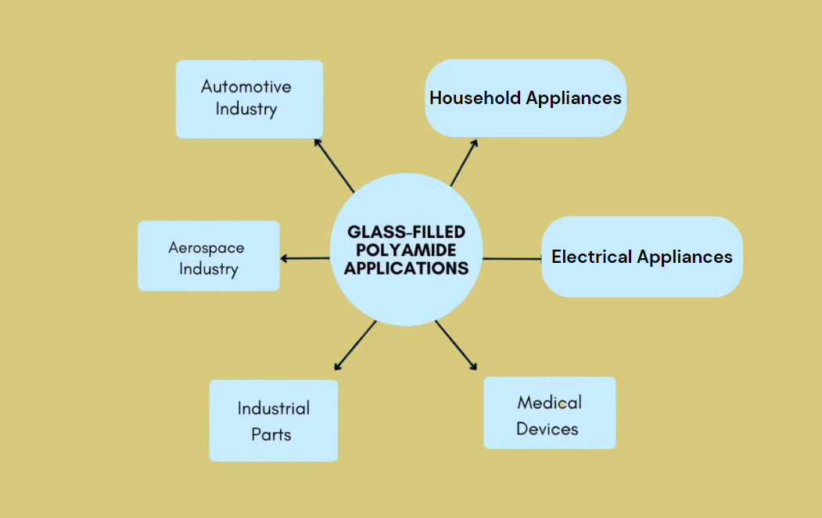

Figure 7 glass-filled polyamide applications

## Industries that commonly use PA+GF and popular products made from this material.

* **Automotive Industry**: PA+GF materials are prominently featured in the automotive sector. They are used for critical components such as intake manifolds, engine covers, structural parts, and under-the-hood components. The lightweight nature of PA+GF contributes to enhanced vehicle performance, fuel efficiency, and durability.

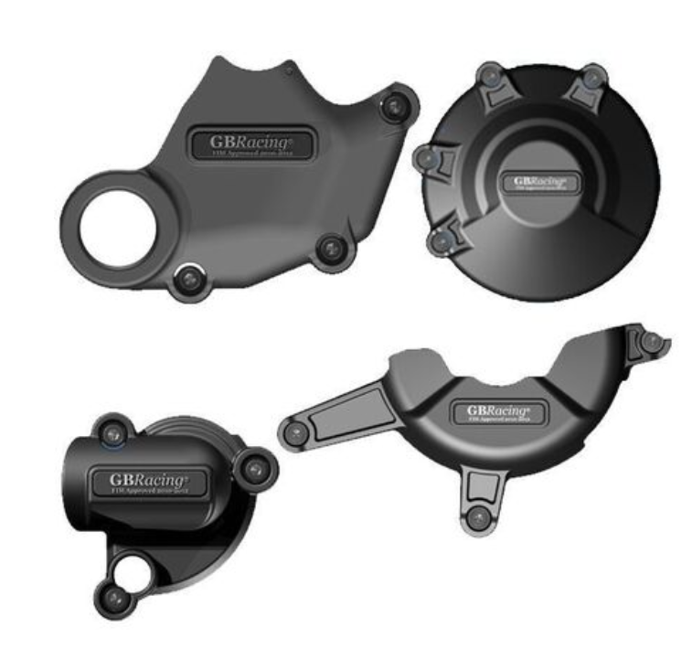

Figure 8 GB Racing Full Engine Cover Set -60made from 60% long glass fibered nylon

* **Aerospace Industry**: The aerospace sector relies on PA+GF composites to manufacture lightweight yet strong components for aircraft interiors. Also, seating structures, cabin panels, and overhead bins are made using this material. The reduction in weight supports improved fuel efficiency and operational cost savings.
* **Electrical Appliances**: PA+GF's electrical insulating properties like huge thermal resistance make it indispensable in the manufacturing of electrical connectors, enclosures, and housings. These materials offer protection for delicate electronic components while providing mechanical strength.

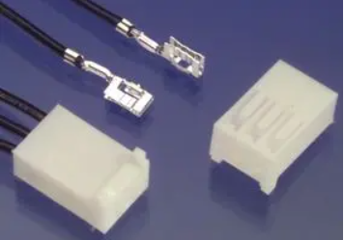

Figure 9 Connector housing made of glass-filled nylon

* **Household Goods**: In the realm of consumer products, PA+GF is found in items such as power tool casings and kitchen appliances. Its combination of strength and reduced weight enhances product performance and longevity.

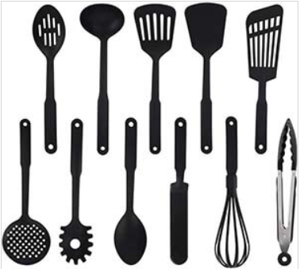

Figure 10 Stirring spoons made up of Nylon

* **Medical Devices**: The medical device industry benefits from the biocompatibility and sterilization resistance of PA+GF materials. They are used in a range of medical equipment, ensuring both mechanical durability and safety in healthcare settings.
* **Industrial Parts**: For industries reliant on heavy machinery and equipment, PA+GF is favored for gears, bearings, and structural components for industries reliant on heavy machinery and equipment. Its resistance to wear, chemicals, and high loads contributes to extended equipment lifespans and reliability.

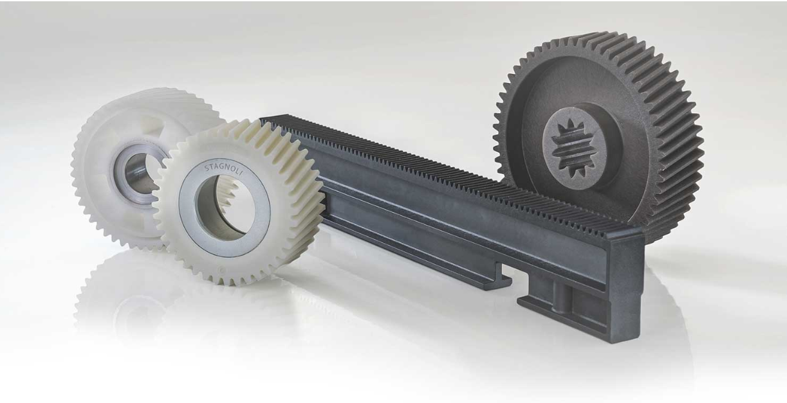

Figure 11 gears made up glass glass-filled polyamide

## Illustrative Case Studies Demonstrating PA+GF Benefits:

1. *Revolutionizing NISSAN Trucks with high mechanical strength and lightweight PA+GF engine cover:*

Nissan Europe sought to reduce engine cover weight and production costs for their Pathfinder and Navara trucks amidst rising gasoline prices and stringent fuel-economy standards. They collaborated with MCC Mondragon Corporation Cooperativa, Fagor Ederlan, and Maier, along with DuPont's material science expertise, to find innovative solutions.

Two critical engine cover components, the cylinder head cover and front engine cover, were replaced with lightweight polymer parts. The cylinder head cover used DuPont™ Minlon® mineral-reinforced nylon resin, offering high performance in terms of stiffness, strength, and chemical resistance. The front engine cover utilized a 30% glass-fiber reinforced grade of DuPont™ Zytel® nylon resin, ensuring resistance to heat, chemicals, and mechanical stress.

The benefits were significant: a 40% reduction in weight, cost savings of 30-35%, and no loss of performance. These high-performance polymer parts not only met the demanding requirements of engine components but also opened the door for considering the replacement of other metal engine parts in the future.

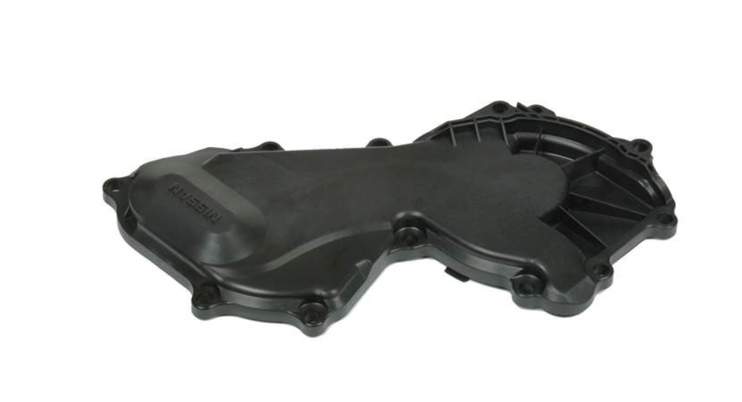

Figure 12 Nissan engine cover made of glass-filled nylon.

1. *Omega Leads - Custom Cable Assembly Manufacturer-Enhancing Electrical Connectors with PA+GF Material*

Omega Leads recognized a growing demand for customized electrical connectors in the electronics industry. OEMs and aftermarket manufacturers sought connectors without mating components in their bills of materials which created a unique challenge. Omega Leads collaborated with customer engineers to devise a solution. They identified the potential of Polyamide with Glass Fiber (PA+GF) material for these connectors through extensive research. The benefits of this choice included rigorous testing, high-quality PA66 glass-filled nylon housing, and manufacturer-specific contacts.

Results: Omega Leads successfully addressed the demand for custom connectors, offering a comprehensive solution that met stringent quality standards. By leveraging PA+GF material, they enhanced their portfolio of value-added services and delivered competitive pricing.

# Challenges and How to Overcome Them

1. **Exposed Glass Fiber**:

Challenge: Glass fiber exposure due to material flow differences.

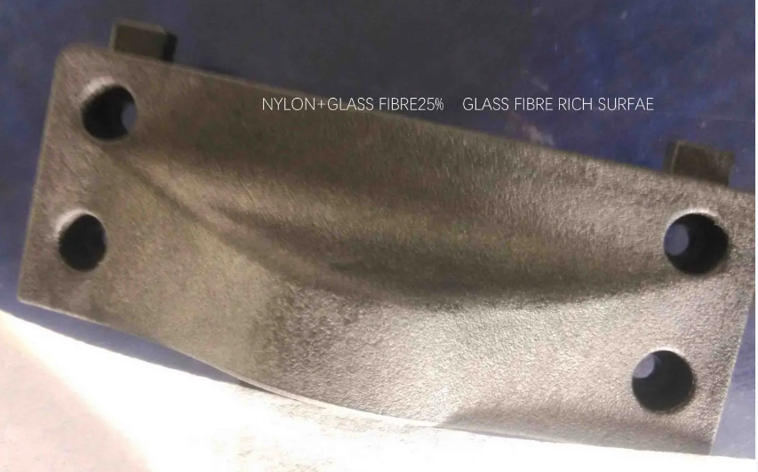

Figure 13 glass fiber rich surface (source :https://www.plasticmoulds.net/why-and-how-to-prevent-glass-fiber-rich-surface.html)

Solution:

* Increase injection speed
* raise mold temperature to reduce contact resistance
* lower temperature
* ensure clean raw materials
* apply a treatment agent to the material
* consider forced drying.

1. **Burning**:

Challenge: Localized carbonization or scorching caused by high temperatures during high-speed injection.

Solution:

* Adjust feeding speed
* reduce mold temperature
* pre-dry modified nylon materials, or use non-drying modified nylon.

1. **Dents**:

Challenge: Dents may result from insufficient filling material, improper gate placement, small runners and gates, or uneven product wall thickness.

Solution:

* Adjust material volume or gate placement
* Increase runner and gate size
* Modify the mold
* Raise injection pressure.

1. **Glass Fiber Silver Streak**:

Challenge: Silver streaks with bright spots, particularly near material flow areas.

Solution:

* Increase injection speed
* Elevate mold temperature
* Boost barrel temperature and back pressure
* Minimize temperature fluctuations.

1. **Ripple**:

Challenge: Ripple defects can arise from small gates, tortuous flow channels, uneven section thickness, improper cooling, low melt temperature, or inadequate injection settings.

Solution:

* Modify gate size
* Enhance flow channel design
* Ensure uniform section thickness
* Adjust cooling systems, raise melt and nozzle temperatures
* Increase injection pressure and speed.

1. **Shrinkage and Warping**:

Challenge: PA+GF materials may experience shrinkage and warping during cooling and solidification. Unfilled Nylon has a typical shrinkage ratio of 1.5%, but 30% glass-filled Nylon has a shrinkage of 0.3% in the flow direction and 1.0% shrinkage in the cross-flow direction.

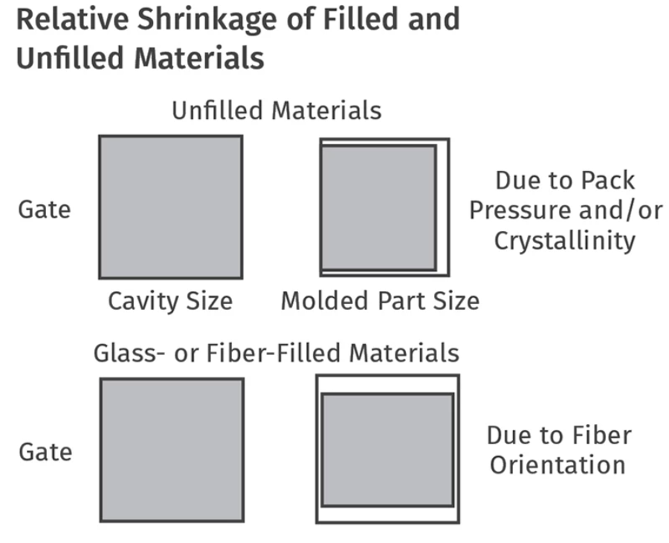

Figure 14 relative shrinkage of filled and unfilled glass materials (source:https://www.ptonline.com/articles/hitting-the-numbers-part-2)

Solution:

* Address shrinkage and warping by optimizing mold design
* Controlling cooling
* Adjusting gate placement
* Maintaining proper melt temperature
* Ensuring uniform wall thickness.

1. **Overflow Edge**:

Challenge: Thin flash along parting lines due to insufficient mold clamping force.

Solution:

* Increase clamping force
* Eeduce injection speed
* Implement multi-stage injection
* Initiate pressure sooner
* Lower barrel and mold wall temperatures
* Reduce holding pressure.

Also, ensure that operators and technicians are well-trained in PA+GF injection molding processes. Experienced personnel can identify and address issues effectively.

# Conclusion and Future Trends

In the world of plastic injection molding, the combination of Polyamide and Glass Fiber (PA+GF) has given birth to a remarkable material. PA+GF stands strong with enhanced strength, hardness, stiffness, and heat resistance, making it a go-to choice in various industries. It has extended its capabilities to automotive, aerospace, electronics, household items, medical devices, and industrial components. As we look ahead, PA+GF's journey is far from over. The glass filled Nylon Molding Market is growing at a +6.9% CAGR during the forecast period 2023-2032. The increasing interest of individuals in this industry is the major reason for the growth of this market and is expected to reach USD 18.3 Billion.